RESEARCH PAPER

Citizens’ Participation and Gamification – Lessons Learnt from Previous and Recent Participation Boosts in Germany
2016 INTERNATIONAL SYMPOSIUM “Citizen Participation and Collaboration in Promoting Open Government”, March 8, l'Université Paris 1 Panthéon-Sorbonne

Dr. Kai Masser
German Research Institute for Public Administration (GRIP) Speyer
Lecturer, German University of Administrative Sciences Speyer
Dr. Linda Mory
Project Consultant at the Integration and Certification Center, SAP SE
Lecturer, German University of Administrative Sciences Speyer

DRAFT VERSION

Content
1 Introduction: The Discussion of Citizens’ Participation 3
Part A: Citizens’ Participation 3
2 The Participation Dilemma (in Germany): The more Possibilities there are, the more the People demand and stay absent 3
2.1 Participation Boosts in Germany since “1968” 3
2.2 The Gap between Important Issues and Influence on the Decision-Making: “Were have all the Voters Gone”? 4
3 The Participation Dilemma (in Germany) 2: “You Can't Always Get What You Want … But Do You Get What You Need”? 9
3.1 The Economy of Citizens’ Participation: Political Participation is Not the First Choice (of Self-Actualization) 9
3.2 Selective Utilitarianism and Political Activism: Different Behavior and Different Expectations 11
Part B: Gamification 12
4 Engaging People by Letting Them have Fun 12
4.1 How the Private Sector is Playing Games 13
4.2 How the Public Sector is Playing Games 15
5 Conclusion 17

1 Introduction: The Discussion of Citizens’ Participation
A newspaper article presented the critic of two majors of bigger German cities regarding citizens’ participation about a year ago (FAZ, 19.02.2015). The main points of criticism are:
- Damage of social capital. Opposing positions appear to be irreconcilable. Decisions are leaving deep wounds because of aggressive campaigns and non-objective discussions
- Limited legitimacy of decisions because of low participation rates of only special social groups. Minorities are dominating the majority of the people
- Many of the present-day citizens’ groups are consisting of resentful people who are only accepting their own opinion
- Elected representative bodies like the city council are disempowered
The article gives a focused summary of the recent discussion about citizen participation in Germany. The advocates of direct democracy and citizens’ participation are using the same arguments but achieve the opposite results. More involvement of all parts of the society could be achieved and problems are solved in a more objectively oriented manner (by deliberative mechanisms). Who is right or are both wrong?
Part A of this paper is dealing with this issue. Part B is analyzing, how “gamification” can help to overcome the “participation dilemmas”.

Part A: Citizens’ Participation

2 The Participation Dilemma (in Germany): The more Possibilities there are, the more the People demand and stay absent
Nearly all empirical surveys in Germany about attitudes towards democracy and participation have agreed in one respect: People want a greater influence on the political decision-making. For instance, a nation-wide survey in 2011 based on a representative random sample determined that 81% of the German Population wishes more political participation opportunities. Moreover, 60% declared their willingness to take part in participative processes besides elections. (Nanz / Kamlage 2013, 12).
On the one hand, there is still the request for more participation opportunities on the other hand participation opportunities in Germany have become significantly larger over the last forty years.

2.1 Participation Boosts in Germany since “1968”
In response to “1968” a first “participation boost” took place in West Germany. All over the country, protest campaigns and movements (citizens’ groups) were shooting up after “1968”. More and more decisions of parliaments and municipality councils where called into question. Citizens requested more participation and involvement! Consequently, various hearing and consultation procedures and rights where incorporated into the conventional political and administrative procedures (e.g. planning approvals and authorizations). It felt like a “participatory revolution” at that time (Geißel 2008, Vetter 2008, Masser 2010). Recent developments in the field are:
- Freedom of Information Acts on the federal level and in 11 of the 16 federal states (2006ff.). By law, every person can demand official information (documents) without presuppositions.
- The most recent amendment of the administrative procedure act (2013). Whenever a plan or a project might have a considerable impact on third parties, the responsible authority has to inform the affected public. At an early stage, non-conventional (deliberative) participatory instruments should be applied. The affected public should have the opportunity to react and respond to the plans before any decision is made in order that different alternatives could be envisaged. (Masser / Ritter / Ziekow 2014, 1ff.)
Beginning with the early nineties of the last century a second or “new wave” of participation opportunities focusing on codetermination of citizens emerged. (Very similar in many OECD-Countries):
- Citizens’ initiatives and referendums at the municipal level but also in federal states but with different quorums (petitioner and voter participation) and permitted issues, e.g. budget issues(!) not allowed.
- Direct ballot (sometimes recall as well) of mayors (in all federal states) and county commissioners (district administrators) (all non-city states except Baden-Württemberg).
- In some federal states the opportunity to have influence on the persons in the councils by choosing specific candidates from the tickets (at the bottom the attempt to have electoral lists / the proportional voting sys-tem and the majority election system of single persons at the same time; very sophisticated).
In addition to those legally structured participation opportunities, there are extended possibilities for informal participation on all levels (Gabriel / Kersting 2014, 44). These aim to enhance citizen’s participation by involving citizens into political decision-making.
Especially the direct ballot of mayors and county commissioners did not yield the expected success. Turnout rates are poor, very often below 50%; especially the turnout rates of second ballots are very low. Moreover, in the state of Brandenburg some elections of county commissioners were void due to too low voter participation, less than 15%. Thus, especially in respect of the district commissioners the direct ballots are called into question. It seems that people decide to vote according to their (personal) importance of the election. (Lückemeier, 12).

2.2 The Gap between Important Issues and Influence on the Decision-Making: “Were have all the Voters Gone”?
Klages and Vetter (2013) make the diagnosis of a widening gap between politics and the people (in Germany). If we look at the development of the turnout rates in Germany since 1945 it becomes clear that there is a remarkable decreasing voter turnout especially at the municipal level. At the state and in particular at the federal level voter turnouts have cyclical fluctuations but remain relatively stable. The turnout levels since the 1990ties match the delineated order of importance (of the different hierarchical political levels) above (Figure 1) perfectly. Elections at the federal state level have the highest voter turnouts followed by the state level. Voter turnouts at the local and municipal level experienced a dramatic decline. (This concerns the elections for the European Parliament on a larger scale).
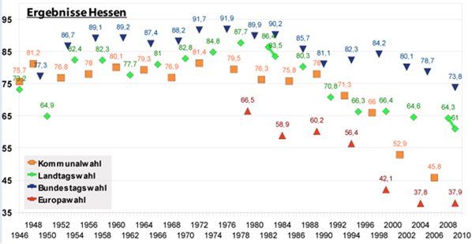
Municipal elections
State elections
Federal elections
European elections
Figure 1: Election Turnout at Different Levels of Government in Hessen 1946-2010, percentages
Is it coincidence that voter turnouts at the municipal level dropped dramatically at the very time participation opportunities where introduced especially at the municipal level and only partly at the state level but not at the federal level (second participatory boost)?
Since people have the opportunities of direct ballots (directly elect their mayor) and, pre-eminently, have the ability to decide by referendums (in Hessen at the municipal level since 1992) election turnouts declined dramatically. It appears that the more the people have an immediate influence on the (political) decision making, the less the governing parties and persons got importance. On the other hand, federal elections seem to have a very high significance, but people have no immediate influence. In Germany, the people cannot elect persons directly at the state and the federal state level. Furthermore, at the federal state level referendums are not eligible.
Huge parts of the approximately 80% of the German population which wishes more political participation opportunities (chap. 1) does apparently not take part in elections, especially at the municipal level. Moreover, many of the 60% of the people, which declared their willingness to take part in participative processes besides elections, do not take part in municipal elections. (We are coming back to this very interesting item later). Are elections just not enough, for instance do people want more detailed influence on community issues?
There has been a recent “movement” towards participatory budgeting (PB) in many towns and cities in Germany. The underlying idea behind the PB was that the budget determines the most important settings of the municipal agenda (Bertelsmann-Stiftung 2004). Therefore, a PB seemed to be a silver bullet to come to a coproduction of politics, administration and the citizens of community live. However, the bullet did not hit the target the first time. About twelve years ago, there was a first attempt to introduce PB in local government. Six (relatively small) pilot-cities introduced PB. The moment the state funding of the project ended, four of the six pilot-cities stopped the project immediately. The reasons the municipality officials gave for quitting the project are significant:
- Only twenty people attended the PB informational town meetings. A bad ratio of (much) effort to (few) results.
- The success of the PB was a short-lived. Very quickly only the “usual suspects” (professional activists, “policy nerds”) were participating.
- “No money: You should not ask citizens about their wishes and demands if there are no opportunities to put them into practice”. There was not enough financial scope for PB.
Retrospectively it looks like most of the PB1.0 approaches focused upon the delivery of information. Politicians and civil servants (concerned with budget matters) took the chance to comment and interpret the complicated matters of a public budget (together with the hardship of the day to day work of a civil servant) to the public. Supposedly, people did not wanted to get lessons about the municipal budget in their leisure time. Moreover, the influence of the citizens on the budget was very unclear or obviously non-existent. The following chart indicates that something changed starting around the year 2010:
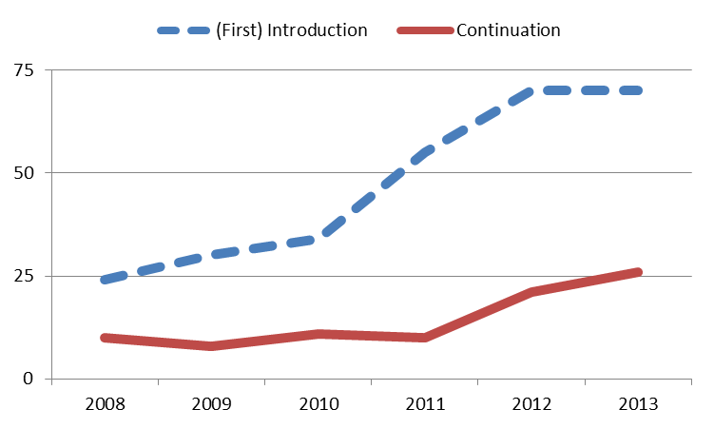
Figure 2: Number of municipalities introducing and continuing a PB in Germany, 2008-2013. Data Source: Status Report on Participatory Budgeting in Germany
From 2008 to 2011 all municipalities which newly introduced a PB did not continue it the following year or, if some did, a corresponding higher number of municipalities quit the same year. However, only about 10 municipalities carried on their PB for a certain time. Since 2011 the number of municipalities to continue the PB has risen from 10 (2011) up to 26 (2013). Although the number of municipalities (up to 70 in 2012/13) which quit continuing the PB risen at the same time (Due to a higher number of municipalities which introduced / tried the PB) there is a small but visible trend that more municipalities use a PB as a regular feature of the city planning. (Nevertheless, compared with the approximately 2.000 cities in Germany, 26 is a rather small number).
At first sight, the reason for the turnaround could be attributed to Web2.0. More and more municipalities used Web2.0 applications to run their PB. On the other hand, Web2.0 was already used by very ambitious and thus complicated PB-approaches like the Freiburg and Hamburg (see Figure 4). The use of Web2.0 appears not to be sufficient to make a PB flourish. In fact, the simplification and gamification of the concept seems to be the key to success. This goes without saying, that Web2.0 technologies support gamification greatly. A prominent and the most successful example of the new type of PB2.0 is the City of Potsdam (the capitol of the federal State of Brandenburg). Making and choosing proposals captures the essence of that kind of PB. Citizens can suggest all kinds of projects and ideas. Every year (or now every two years due to the new bi-annual budget period) 20 proposals are selected with a guarantee of implementation. The concept is reminiscent of TV shows like “American Idol”:
- In a first step, proposals can be discussed and rated (e.g. by a “like-scale” from 1=very good to 5=very poor). From this a given amount of the highest rated proposals remain, e.g. 100.
- The second step is a review of the highest rated proposals by the municipal administration and sometimes also by the parliamentary groups (which have shown interest in the PB).
- The proposals which “survive” the review process during the second step then occasionally go through another selection process: The short-list of proposals is rated a third time via the Internet (accompanied with mailed surveys), with every citizen able to vote for the proposals.
- Then, finally, the city or town councils have to decide about the final remaining (20) proposals. If a PB-proposal is rejected by a municipality council, the reasons should be explained to the PB participants.
However, still only small groups of citizens took an interest in the PBs. Potsdam, the capitol of Brandenburg, attained by far the best result, 5% of the eligible voters took part.
Number of Participants |  | Absolute Numbers |  |  | % of the Electorate
City | Year | "Face-to-Face" | Online | Interview | "Face-to-Face" | Online | Interview
Freiburg | 2009/10 | 206 | 1,861 | 2,575 | 0.13 | 1.22 | 1.68
Hamburg | 2009 | - | 552 | - | - | 0.04 | -
Marzahn-Hd. | 2007 | 50 | - | - | 0.02 | - | -
Potsdam | 2011 | 195 | 1,720 | 3,455 | 0.16 | 1.38 | 2.76
Trier | 2011 | - | 2,322 | - | - | 2.90 | -
Figure 3: Turn-Out-Rates of PBs, Participation-Method Differentiated (Source: Masser / Pistoia / Nitzsche (2013)
If we look at the turnout rates of municipal referendums in Hessen since their introduction, we recognize that participation of the people is very volatile but sometimes reaches 80%.
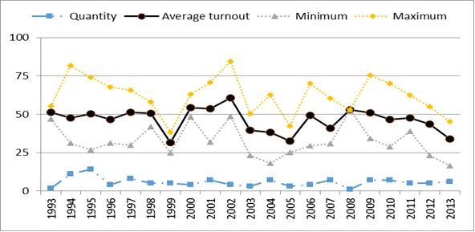
Figure 4: Turnout Rates of Municipal Referendums in Hessen, 1993-2013, percentages
The average turnout rate is about 50%, which is more or less in line with the turnout rates of municipal elections in Hessen. In the year 1994, the highest turnout was above 75% and the lowest near 25%. In 2002, participation in general was very high, in 1999, 2005 and 2013 rather low. In 2013, there were 431 municipalities in Hessen. Referendums had taken place in less than ten of the municipalities since 1995. To prevent very low participation in Switzerland all referendums are jointly executed (at four fixed) dates. In Germany, it is rather the exception to the rule that referendums are executed at the same date together with for example elections or other referendums. Therefore, the participation is more volatile than in Switzerland because if there is just a single referendum (and not a few at all levels of government) the participation depends much more upon the concernment of a person by a subject. (Masser / Mory 2014, 11). Turnout Rates of (scarce) state referendums in Hessen demonstrate the same pattern. A participation of 81% seems to be the upper limit. In general, the turnout rates are very different.
In a first sum up, we can state about the participation in Germany:
- There is a group of approximately 20% of the people who do want to participate at all
- The majority of the people is only getting active and is taking action if it seems significant or they are personally concerned (e.g. their property)
In conclusion, the participation dilemma is apparent. On the one hand, there seems to be a disparity between which matters people want to decide and on the other hand, whether it is permissible. The political elites (parties) are not willing to give people more influence at the (federal) state level. However, most of the people consider that the most significant decisions are been made at the federal government level. Furthermore, most participation offers concern the area of local planning. Without the power to decide. It is therefore no paradox that people do not use the existing participation offers but demand more at the same time.

3 The Participation Dilemma (in Germany) 2: “You Can't Always Get What You Want … But Do You Get What You Need”?
A societal value change occurred in all OECD countries over the last century. Klages (2001) has summed up the societal value change by the formula “a shift from the performance of one’s duty and obedience to self-expression and development”.
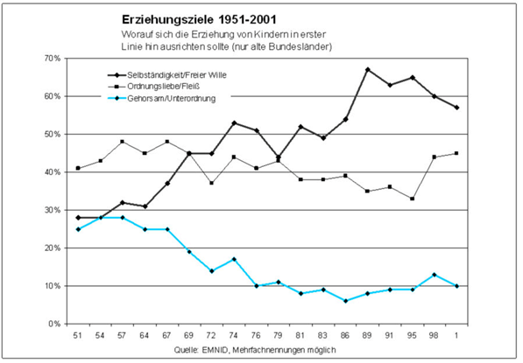
Figure 5: Change of Educational Goals in the German Population, 1951-2001
Educational Goals 1951-2001
What is most important in education? (Only Western German States)
authonomy / free decisions
orderliness / diligence
obedience / subordination
However, the general thrust of the societal value change is grounded in a need for personal independence and individual opportunities of action which results in a need to (co-)decide on matters concerning one’s own affairs (see Klages/Vetter 2013, 18). The taking-over of tasks, commitment and motivation is based upon own views, thoughts, values and belief.

3.1 The Economy of Citizens’ Participation: Political Participation is Not the First Choice (of Self-Actualization)
The city of Mannheim (MA) complied a “democracy audit” in 2013 based on a representative survey among citizens (Van Deth / Schmitt-Beck / Odrakiewicz, 2013). We, the German research institute for public administration (FöV) did a similar survey in 2014 on behalf of the city of Gießen (GI). Both surveys contained a question about civic virtues. The respondents could grade their judgement of a list of virtues on a scale from “very important” to “totally unimportant”.
Figure 6: Judgement of Civic Virtues (Two Democracy Audits in German Cities), average (arithmetic mean)
0=“totally unimortant“ / 10 “very important“
Apparently, people judge political activity or involvement much less important than to take part in elections. This is in line with our findings in chapter 2.2. (see also Ewen / Gabriel / Ziekow, 2013, 102) People mainly take part in elections or referendums in large numbers but do not participate in other, more intensive and time consuming participation measures to a larger part. Many value and volunteer involvement studies have shown that only very few citizens do volunteer work in the political arena (Klages / Masser 2009, 38ff.). Compared to other branches like religion or sport political volunteering often is very time consuming.
According to the findings of our empirical surveys (citizens’ surveys) there are two (rather three) major determinants of citizens’ participation:
- The effectiveness of a participation instrument, that is how binding are the results and how much influence do I have
- The cost of involvement
  - especially the time requirement
  - and the inconvenience, for instance peer pressure, uncertainty in dealing with political activists
There is a big gap between the rather high estimation of the effectiveness of the involvement in political parties (and in planning processes) and the low number of membership and contribution. (The percentage of members of political parties of the population in Germany is below 3% (Masser 2013, 317)). Catching the attention of the media is also recognized very effective but obviously difficult to achieve (especially for “ordinary people”).

Figure 7: Turnout and Effectiveness of Participation Instruments, Democracy Audit Gießen 2014, percentages
The most popular forms of participation (citizens’ surveys, signature collection, boycott of products and voting) where estimated very effective and obviously do not take much time and are suitable for everyone without the need for higher education or obligations. This is equally applicable to referendums, which are very popular as well. (Klages / Masser 2009, 51). The success of citizens’ participation, that is the number of participants, seems to be dependent on the cost-benefit estimations of the citizens.

3.2 Selective Utilitarianism and Political Activism: Different Behavior and Different Expectations
The citizen surveys carried out by the German Research Institute for Public Administration (GRIP) Speyer consist of two independent components. At the core, there is a random sample of personally addressed people. Additionally, there is an online survey open to everyone. The latter group recruit itself-through their interest in the subject of the survey. The result is a big difference between the groups, e.g. open survey group is older, male dominated and have higher education. Moreover, these people in general are more voluntarily active and more interested in politics. (Klages / Masser 2009).
Figure 8: Citizen Participation Involvement of Representative and Politically Active (open survey) Groups, Democracy Audit Gießen 2014, percentages
The more participating group of the open survey is in particular more active in online consultations, contacting politicians and the administration, citizens’ initiatives and groups as well as signature collection campaigns.
In a system of representative democracy, the economy of citizens’ participation for the group of the political activists seems not advantageous. These people spent lots of time and efforts e.g. in online forums, citizens initiatives and so on, but do not have significantly more power than any other citizen. This is insufficient because the benefits (decisions) are not in line with costs. In other words, political volunteer involvement has a bad cost-efficiency ratio unless you have power. This may explain that political activists are dissatisfied with the political system (in Germany). On the hand, the majority of the people benefits. The division of labor between government and administration on the one hand, and the citizen on the other hand together with the opportunity to have significant influence by elections and referendums seem to be very attractive because of a very good cost-benefit ratio (very less time and effort with rather high influence). Therefore, the political system in Germany seems to be in line with the needs of the majority of the people. Without doubt, most of the people would appreciate more influence without significantly more effort.

Part B: Gamification

4 Engaging People by Letting Them have Fun
In recent years, the term “gamification” came up. Gamification is a concept of the participation of customers, employees or even citizens. Like in many cases of new concepts, the meaning and content is widely unclear (in the beginning). Many new and not widely explored concepts seem to be buzzwords – the same applies to the term gamification (see Shah (2012), p. 1). In our understanding gamification is about engaging people and looking at what they are motivated and interested in, giving them playful experiences for the benefit of the players and for the benefit of everyone else like companies, customers, co-workers, administrations and government – depending on the scope in which gamification is used.
A formal and widely used definition of the term is from Deterding et al. (2011) who define gamification as “the use of game design elements in non-game contexts” (p. 1). There are other definitions in place such as from Shah (2012) who defines the term as “[…] a way of using game mechanics (e.g., competitive challenges, recognition and rewards) to improve a business process, with the goal of fulfilling business objectives” (p. 1). What all of the definitions have in common is the basic idea of making use of game thinking and game mechanics to engage users in solving problems. Gamification can be used to improve user engagement, return on investment, data quality, timeliness and learning. The techniques of gamification include giving rewards for users completing certain tasks, foster competition and fundamentally making tasks feel like games.
As Shah (2012) points out there are four main elements of gamification programs (p. 1):
• Objective: First of all, it is crucial to identify the business objective in order to know what the organization is trying to achieve. This can be for example to improve adoption rates, to encourage employees in learning, to improve brand awareness, to shorten processes etc.
• Mission: The mission is the breakdown of the business objective and is a set of related task to achieve the business objective. It can have different levels and players can be rewarded for the completion of each level or mission
• Gaming Components: The gaming components form the operational part of the gamification process can be displayed as badges, levels, challenges, leader boards and players
• Well-thought-out design: The effective and well-suited design is one of the most important part of the gamification process. In this regard, the ease of use and an intuitive design is crucial for the overall success of the process
So in order to be successful with gamification a player centered design involves knowing your player, identifying the business objective and mission, understanding human motivation and applying mechanics among other themes. In the private sector (sometimes as well as in the public sector) good examples can be found.

4.1 How the Private Sector is Playing Games
Gamification is highly inspired by the video game industry. Therefore, this huge industry serves as the thought leaders when talking about gamification in the private sector and especially in the software industry. There is one rule for games developer at EA Games, the makers of the popular Madden NFL video game series among others: Game software that does not produce visible joy for the user within seven minutes will be a flop.
When SAP started to re-think its approach to software development a couple of years ago, the company looked at the video game industry for inspiration. In this regard, questions from employees came up such as: Does this mean we can all look forward to using a “Killzone 3″-like interface to enter our travel expenses? The answer to it is “not exactly”, but the general idea behind video game mechanism and intrinsic motivation is very similar. Video games mean big business and SAP came to the conclusion that enterprise software developers can certainly learn a lot from the emotional connection gamers make with the likes of the aforementioned Killzone 3, which sold over 500,000 copies in its first week of release in North America.
In chapter 2.2 we explained how a game show concept (e.g. American Idol) re-animated and saved the participatory budgeting (PB) approach in Germany. The mentioned company SAP uses exactly the same concept to improve its products (software). It is striking how similar the approaches are: To improve existing software and enhance the functionality there is a program named “Customer Connection”. User (customers) are encouraged to post improvement requests and other suggestions on the SAP Customer Influence Platform. Requests and suggestions are discussed in relevant customer groups or special interest groups in order to “collaborate with as many customers as possible and retrieve a ranked backlog (the idea is passed to SAP Development to be evaluated) based upon customer needs”. The “players” act in different roles: 1) “Request Owners” submit and describe their idea; 2) Subscribers, which “vote” for the idea and thus help to prioritize in order to qualify it for the backlog analysis by the company (minimum of 5 subscriptions per request); 3) Followers, which get informed about the progress of the “idea” and make comments on it. Customers receive feedback about whether and how the idea is implemented or a reason why the idea cannot be realized in the current project. Selected improvements are provided e.g. as Service Packs & Enhancement Packages. Customers can therefore use “Customer Connection” specifically to:
- Submit improvement requests
- Discuss on and subscribe for submitted improvement requests
- Track the status of the improvement requests relevant to them
- State whether they want to implement improvements, and if so, which ones
The company reports that customer requests triggered almost 400 product improvements and more than 6,500 customers worldwide make use of them. Customers and citizens acquit the same function, in the first case for the improvement of software products they use and, in the second case, for the evaluation and development of public policies and projects. In both cases, we see the same concept of getting feedback and response by a system from its environment. In evolutionary terms, we could speak of a way of smart adaption. What is really amazing, however, is that there are three identical roles: 1) The facilitator which is in charge for the setting of the “setup defaults” and the rules of the game. 2) The (small group of) active users, customers or citizens, which make requests and proposals and participate in discussions about these. 3) The majority of the “interested audiences”, which vote for or against “the stuff” (thumbs up, thumbs down). It almost seems like these three groups are an eternal part of democracy and client orientation. We find them in the trails ancient Greece in Athens were we have: 1) Facilitating official bodies. 2) Particular citizen-prosecutors, which take the initiative and subsequently counterattack. 3) The polity: Thumbs up / thumbs down. (Literally used in the “panem et circenses” games in ancient Rome).
However, what we learn from the Customer Relation strategy of SAP and the evolution of PB in Germany is, that people are not interested in being involved in complicated details like the drawing up of a budget or the development of a software (programming of code) but rather in outputs and outcomes. Moreover, the different groups of users/citizens have different demands in which way they want to be addressed. However, customer involvement and citizens’ participation seems to be more successful, if means and procedures imply entertainment, suspense and kick. Free democratic elections are not only fair and just, they mean a lot of entertainment and suspense to the civil audience. The primary elections in the USA are a good example: Who will be the candidates? There are a serious of TV-debates of both major parties and a lot of other media attention even if it is just the primaries.
Another way to gamification are (group) challenges. During the “Bankathon” challenges the best new developed and designed financial products are awarded. Within thirty hours, teams have to develop new creative ideas for the digitalization in the financial industry. The best solutions get an award, inter alia a start-up coaching hosted by SAP.

4.2 How the Public Sector is Playing Games
Whereas the private sector is already using gamification for their business purposes, the public sector seems only at the beginning of exploiting gamification for their own purposes and needs. However, there are also some good examples and first approaches from the public sector to use gamification in order to generate citizen participation. One is that of the municipality Ludwigshafen in Germany we started with a project on the renovation of the elevated highway “north”. The elevated highway “north” in Ludwigshafen (at the Rhine) was build up between 1970 and 1980 and needs a complete renovation now. It is a national road which begins as a freeway, goes through the centre of the city and crosses the Rhine (see Figure 1 below).
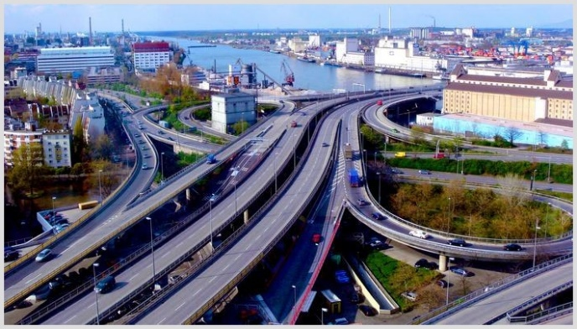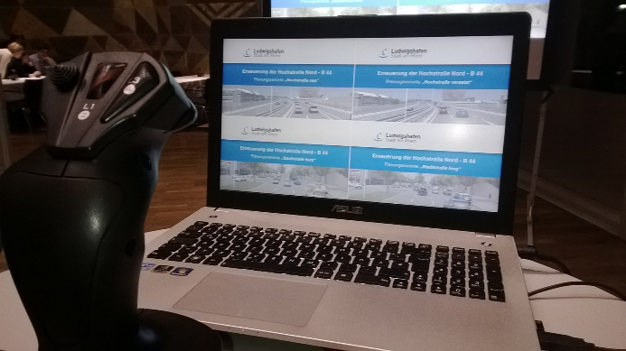
Figure 9: Elevated highway “north” in Ludwigshafen am Rhein, Joystick to drive through the 4 scenarios
The building project will have a major impact on the city and the region. The construction period will be approximately 10 years and the costs will sum up to approximately 300.000.000 Euro. The city decided to involve the population at an early stage. Like in another similar case in German, that of the renovation of the A 6, four alternative planning variants are developed. The solutions varied from a complete re-establishment of the elevated road, two half-elevated versions to a complete new “ordinary” road at ground level. During town hall meetings and on the web the variants are presented and the specifications are explained:
- How long will be the construction period (in the best case (variant) eight years, in the worst case twelve)?
- How much will it cost (Best alternative: € 270 Mill., worst: € 330 Mill.)?
- What will be the noise and exhaust emissions?
- What possibilities for the future development of the city are associated with each variant?

It is the most outstanding feature of the approach that there were virtual 3D-videos for all four scenarios, presented at town hall meetings and on the web. Thus, every citizen could drive through the virtual new roads. After doing that balancing the pros and cons, everyone could give his or her preference to one of the alternatives. Within an online-consultation platform citizens could make comments on the variants and the project and discuss with each other. Finally participants could vote for one of the four options. In most respects (costs, possibilities for city development, etc.) about three out of four of the participants opted for the new road at ground level. In principle the city council is bearing the responsibility for the decision. However, it seems nearly impossible to decide against the clear intention of a majority of citizens. More than 10.000 people did take part in the town hall meetings and particularly the online-consultation. Even if there is a group of citizens, which still prefers the re-establishment of an elevated highway (especially if traffic flow and parking space are preferred goals), the decision in favour of the ground level road could not be questioned. Resistance by a citizens’ initiative will stand no chance.
The examples of the elevated highway “north” in Ludwigshafen points out that in case of (potentially) conflicting goals an early stage involvement of citizens is insufficient. Moreover, it is important to take care of a broad involvement of a rather big number of (relevant) citizens which was achieved through a gamification approach like in the case in Ludwigshafen. The case indicates that a simple participation method and procedure with ludic elements and a clear outcome are very helpful to reach the overall goal. Additionally visualization (3D animation) is helping to translate complicated planning to laymen.
Today all kind of planning software is available (for experts). Regardless of whether one wants to plan a new house or a garden. With the help of 3D simulation, everything can be depicted and be set out in a “game scenario”.
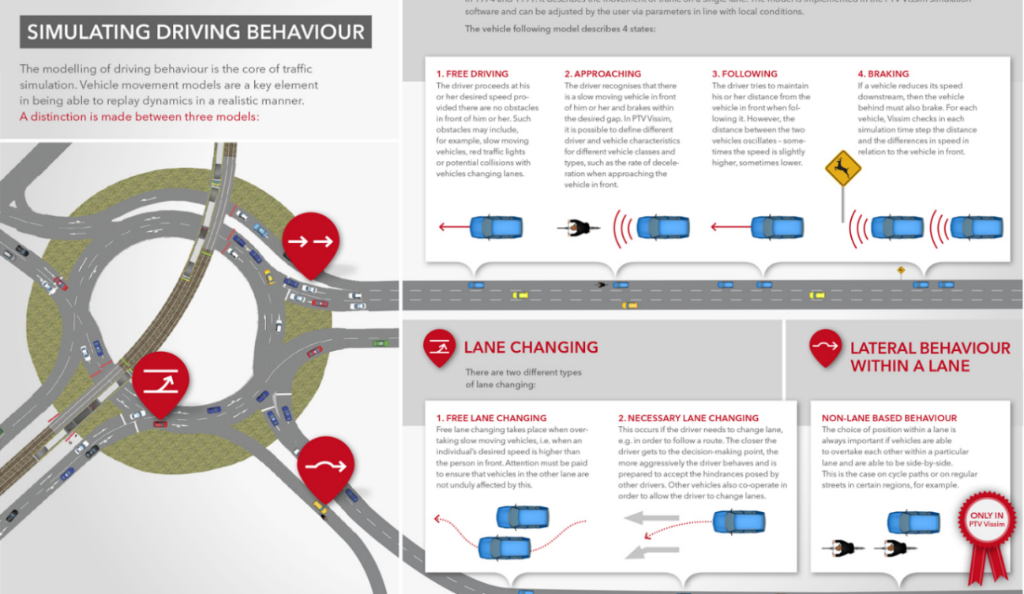
Figure 10: Example planning software “traffic simulation by PTV vissim”
With the help of an appropriate software, it might be possible to integrate citizens into the planning of large-scale projects by multiplayer online games. The task of planning will be to figure out the right setting of the game, e.g. define possible courses of a road, locations for a plant, minimum or expected capacity etc. Therefore, gamification changes the way of how information should be presented. The classical form of (long) written texts, extensive tables (with figures) and construction drawings are not appropriate to give citizens understandable information. E.g. administrative information has to be translated by (digital) visualization and compression into pictures/videos and significant indicators. This transformed information is the basis for the development of games.
One of the foremost favourable features of the winning scenario in Ludwigshafen is the enhancement of city-development opportunities in the city, in particular free spaces for new buildings or green corridors. On other hand, in the 3D-animation there are only vague cubes and potential solutions. What the future will bring is still open. Many cases of city development planning in the past (e.g. of the 60ies and 70ies) did not provide the desired results. Instead of modern and vital neighbourhoods social flashpoints developed. To figure out the risks and potentials of different approaches of the future development of the city gamification might be used. Like for example in the marshmallow challenge, different groups could virtually develop the city. Every group gets the same set of resources and restrictions. Browsergames like “Forge of Empires” already use an interesting plot. The course and outputs of the games (challenges) could deliver valuable information about mistakes to avoid and which factors to encourage.

5 Conclusion
According to the (ongoing) societal value change people want to (co-)decide on political matters. Among other aspects, the societal value change explains that a vast majority of the German people demand more opportunities to have influence on political decisions. At the same time, people have a considerable distrust in politicians and the political parties. Thus, the majority of the (German) people does not want to get enmeshed in policymaking processes. In general people accept that a small elite of politicians and bureaucrats are doing the complex and time consuming business of government and administration. Most of the time the division of labor between citizens on the one side and government and administration on the other hand works well. The majority of the people (about 65-75%) likes to be informed about (all) public issues in order to interfere if necessary (act as veto-players). Additionally, there is a group of approximately 10-15% of the people, which want to be permanently involved in the political decision making besides the parliaments and councils. Participating budgeting and the planning of large scale infrastructure projects serve as examples that gamification can be used as an instrument to meet the demands and requirements of the different groups of a modern pluralistic society:
- (Elected) political bodies, public officials and professional experts: They remain in charge and responsible as decision-makers. However, their role changes. That is, that the consultation of citizens is becoming a part of the preparation of decision-making and their translation into action. Gamification is a convenient measure to involve the citizens. Through the definition of the setting and the rules of “the games”, officials do not lose their decisive (legal) function. On the contrary, used the right way, it enhances the control over the processes of the implementation of political decisions by getting feedback about possible and actual deviations of planned outcomes and, if enough people take part, by enhanced legitimacy.
- The group of (politically) active citizens: This group includes preponderantly male members with income and education above the average. Recurrently retired persons. Without being elected and without any kind of appointment, these persons demand to represent “the people”. Gamification provides an opportunity to this group to be active and play a significant (but time-consuming) part in public affairs. This can cover the search and discussion for public investments or budget savings as well as (the testing of) alternative planning of infrastructure projects. With the help of gamification, it is possible to test and elaborate (e.g.) municipal policy programs. The playing out of (different) projects under different settings and conditions, opportunities and risks become visible. As in the case of quality management in private business, gamification has the potential as a tool to improve public goods with the help of the “customers”.
- The majority of “the citizens”: This group does not want to become politically active in the sense of “face-to-face meetings”. On the other hand, people want to have information about all significant public issues and have the authority to co-decide if necessary. Therefore, all kinds of voting procedures are very appropriate to fulfil this need. Even when is only to “like” or “dislike” a proposal or an opinion. Still better are ratings about the advantages and disadvantages of alternative solutions and scenarios (public investments, infrastructure projects, savings etc.). All in all, the majority is involved by voting procedures without the determination of decisions. Additionally, people do not have to spent much of their time.
The development of alternative scenarios and solutions is possible with the help of the group of active citizens. The setting of goals, rules and framework is the inevitable task of political officials and professional experts. The majority of the people then is in charge to judge the pros and cons of different solutions (developed by games). The decisive factor of games (and gamification) is that it is not for real. It helps to draw real decisions, but it still leaves decisive room for the political arena.

References
Bertelsmann-Stiftung und Innenministerium Nordrhein-Westfalen (2014): Kommunaler Bürgerhaushalt: Ein Leitfaden für die Praxis, available from: http://www.google.de/search?sourceid=navclient&hl=de&ie=UTF-8&rlz=1T4DBDE_deDE277DE301&q=Bertelsmann-Stiftung+und+Innenministerium+Nordrhein-Westfalen%2c+Kommunaler+B%c3%bcrgerhaushalt%3a+Ein+Leitfaden+f%c3%bcr+die+Praxis [accessed 02 May 2015]
Deterding, S., Dixon, D., Khaled, R., & Nacke, L. (2011). From game design elements to gamefulness: Defining “Gamification”. Proceedings from MindTrek '11. Tampere, Finland: ACM
Ewen, Christoph / Gabriel, Oscar W./ Ziekow, Jan (2013): Bürgerdialog bei der Infrastrukturplanung: Erwartungen und Wirklichkeit. Was man aus dem Runden Tisch Pumpspeicherwerk Atdorf lernen kann, Baden-Baden: Nomos
Gabriel, Oscar W. / Faden-Kuhne, Kristina (2011): Auswertungen einer Befragung vor dem Volksentscheid zu Stuttgart 21 (Ergebnisse einer repräsentativen Erhebung, durchgeführt von Infratest dimap), available from: http://www.bertelsmann-stiftung.de/fileadmin/files/BSt/Presse/imported/downloads/xcms_bst_dms_35291_35356_2.pdf [accessed 09 May 2015]
Gabriel, Oscar W./Kersting, Norbert (2014): Politisches Engagement in deutschen Kommunen. Strukturen und Wirkungen auf die politischen Einstellungen von Bürgerschaft, Politik und Verwaltung, in: Bertelsmann Stiftung/Staatsministerium Baden-Württemberg (Hrsg.): Partizipation im Wandel. Unsere Demokratie zwischen Wählen, Mitmachen und Entscheiden, Gütersloh 2014, p. 43-181
Geißel, Brigitte (2008): Wozu Demokratisierung der Demokratie? – Kriterien zur Bewertung partizipativer Arrangements, in: Vetter, Angelika (ed.): Erfolgsbedingungen lokaler Bürgerbeteiligung, Wiesbaden, p. 29-49.
German Federal Agency for Civic Education, available from: http://www.bpb.de/politik/grundfragen/parteien-in-deutschland/42226/zahlen-und-fakten accessed 09 May 2015] [accessed 09 May 2015]
Hessisches Statistisches Landesamt (Statistische Berichte) (2011): Die Kommunalwahlen am 27. März 2011. Endgültige Ergebnisse der Gemeindewahlen und der Kreiswahlen (Kennziffer: B VII 3-2 - 5j/11), p. 6., available from: https://www.destatis.de/GPStatistik/servlets/.../BVII3-2_5j11.pdf;jsessionid... [accessed 09 May 2015]
Kaufmann, Bruno / Büchi, Rolf / Braun-Binder, Nadja (2005): Guidebook to Direct Democracy, Bern: Graf-Lehmann AG
Klages, Helmut (2001): Werte und Wertewandel, in: Schäfers, Bernhard/Zapf, Wolfgang (Hgg.): Handwörterbuch zur Gesellschaft Deutschlands, 2. Auflage, Opladen, p. 726–738
Klages, Helmut und Masser, Kai (2009): Das „Speyerer Bürgerpanel“ als Element beteiligungsbasierter Demokratie auf der lokalen Ebene. Die Bürgerbefragung „Unser Nürtingen – unsere Werte“ 2008 als Beispiel, Speyer: Deutsches Forschungsinstitut für öffentliche Verwaltung, Speyerer Forschungsberichte 261
Klages, Helmut / Vetter, Angelika (2013): Bürgerbeteiligung auf kommunaler Ebene. Perspektiven für eine systematische und verstetigte Gestaltung. Modernisierung des öffentlichen Sektors, Berlin 2013
Kubicek, Herbert / Lippa, Barbara / Koop, Alexander (2011): Erfolgreich beteiligt? Nutzen und Erfolgsfaktoren internetgestützter Bürgerbeteiligung – Eine empirische Analyse von 12 Fallbeispielen, Gütersloh 2011
Lehrke. Jesse P. / Masser, Kai (2015, forthcoming): Leviathan 2.0: Reinforcing the Social Contract by Open Security, Paper to be presented at the 2015 IIAS Congress Rio de Janeiro, Brazil, 22 to 26 June 2015
Lückemeier, Peter, not dated, Die Direktwahl von Bürgermeistern in Hessen - Fünf Erfahrungen – Reihe „Kommunalpolitik“ der Konrad Adenauer Stiftung, Materialien für die Arbeit vor Ort Nr. 5, available from: http://www.kas.de/wf/doc/kas_3515-544-1-30.pdf?040615164903 [accessed 28 April 2015]
Masser, Kai / Ritter, Tobias / Ziekow, Jan (2014): Erweiterte Bürgerbeteiligung bei Großprojekten in Baden-Württemberg. Abschätzung der Auswirkungen der Verwaltungsvorschrift „Bürgerdialog“ und des „Leitfadens für eine neue Planungskultur“ der Landesregierung, Speyerer Forschungsberichte 275
Masser, Kai / Mory, Linda (2014): Citizens' participation: Is citizens’ participation killing elecion turnouts - disillusionment with politics or a normal adaptation to the societal value change?, research paper presented at the 2014 EGPA Annual Conference, Speyer, Germany 10-12 September 2014, available from: http://conference.iias-iisa.org/uk/ConferenceCalendarDetail.awp?P1=3&P2=78 [accessed 12 May 2015]
Masser, Kai / Pistoia, Adriano / Nitzsche, Phillip (2013): Bürgerbeteiligung im Web. 2.0. Potentiale und Risiken webgestützter Bürgerhaushalte, Wiesbaden: Springer, partly also available from: http://www.buergerhaushalt.org/en/article/participatory-budgeting-its-critics-see-it [accessed 12 May 2015]
Nanz, Patrizia / Kamlage, Jan-Hendrick (2013): Entwicklungen der partizipativen Demokratie in Europa, in: Bürgerbeteiligung in Deutschland und Europa, Zeitschrift für Gemeinschaftskunde, Geschichte, Deutsch, Geographie, Kunst und Wirtschaft, Heft 65-2013, Stuttgart: Landeszentrale für politische Bildung Baden-Württemberg
Nicholson, S. (2012): A User-Centered Theoretical Framework for Meaningful Gamification. Paper Presented at Games+Learning+Society 8.0, Madison, WI, available at: http://www.quilageo.com/wp-content/uploads/2013/07/Framework-for-Meaningful-Gamifications.pdf, accessed: 12/30/2015
SAP (2011): The Gamification of SAP, available at: http://scn.sap.com/people/tim.clark/blog/2011/03/04/the-gamification-of-sap, accessed: 12/30/2015
Shah, A. (2012): Gamification: It’s all About Processes, in: Cognizant, May 2012, available at: http://www.cognizant.com/InsightsWhitepapers/Gamification-Its-All-About-Processes.pdf, accessed: 12/30/2015
Van Deth, J.W. / Schmitt-Beck, R. / Odrakiewicz, S. (2013): Demokratie in Mannheim. Ergebnisse des ersten Demokratie Audits Mannheim, Stadt Mannheim
Vetter, Angelika (2008): Institutionen und lokale Wahlen: Wo bleiben die Wähler?, in: Vetter, A. (ed.), Erfolgsbedingungen lokaler Bürgerbeteiligung, Wiesbaden: Springer, p. 49-72

http://www.faz.net/aktuell/politik/inland/gruende-gegen-direkte-demokratie-auf-kommunaler-ebene-13432408.html.
Information also available from: http://www.bertelsmann-stiftung.de/de/presse-startpunkt/presse/pressemitteilungen/pressemitteilung/pid/umfrage-buerger-wollen-sich-an-politik-beteiligen/?tx_rsmbstpress_pi2[page]=28&cHash=00c77b5fe68ff8e349dda5f81161dc0a [accessed 27 April 2015].
See e.g. http://www.statistik-mv.de/cms2/STAM_prod/STAM/de/start/_Landeswahlleiter/Landeswahlleiter/kommunalwahlen/Direktwahlen/index.jsp [accessed 28 April 2015].
See e.g. http://www.wahlen.brandenburg.de/sixcms/detail.php/bb1.c.191073.de [accessed 28 April 2015].
See e.g. http://www.sr-online.de/sronline/nachrichten/politik_wirtschaft/buergermeister_wahlen_luckas_parteien100~print.html [accessed 28 April 2015].
Source: State Returning Officer, available from: www.wahlen.hessen.de [accessed 2 April 2015].
The Website “buergerhaushalt.org/en” monitors PB activities in Germany.
See http://www.buergerhaushalt.org/en/statusberichte. The website monitors the development of BP in Germany permanently.
At a first glance a lucid explanation, see Masser, K., Pistoia, A. und Ph. Nitzsche, 2013.
In GB „Pop Idol“, in Germany „Deutschland sucht den Superstar“.
Source: Statistical Office of the Federal State, available from: http://www.statistik-hessen.de/themenauswahl/wahlen/daten/nach-gemeinde/index.html [accessed 2 April 2015].
Source: State Returning Officer, available from: http://www.wahlen.hessen.de/irj/Wahlen_Internet?cid=1cf3c4ce36580e81f03f670ddf1edf78 [accessed 2 April 2015].
Based on annual representative sample surveys of the German population from 1951 to 2001 by the renowned EMNID-Research Institute (Masser and Mory 2014)
Mannheim is a regional center in a metropolitan area (Rhein-Neckar) with approximately 315.000 inhabitants. Gießen is a university city with approximately 80.000 inhabitants.
The Speyer citizens panel is documented in several research reports (published by GRIP), available (in German) as downloads: http://www.foev-speyer.de/publikationen/pubdb.asp?reihen_id=1.
https://influence.sap.com/ct/c_f.bix
See e.g. https://www.bankathon.net/#results_menu
Everything about the project and the road: http://www.ludwigshafen.de/nachhaltig/city-west/.
The final report of the participation process is published here: http://www.ludwigshafen.de/fileadmin/Websites/Stadt_Ludwigshafen/Nachhaltig/City_West/Buergerbeteiligung/LU_Auswertungsbericht_Stand20140317_final.pdf.
Try https://ludwigshafen-diskutiert.de/.
http://marshmallowchallenge.com/Welcome.html.
https://en.forgeofempires.com/.

